# New Hire Process:

New employees are created into SailPoint using below form. Fields marked with a (*) are mandatory, rest are optional.

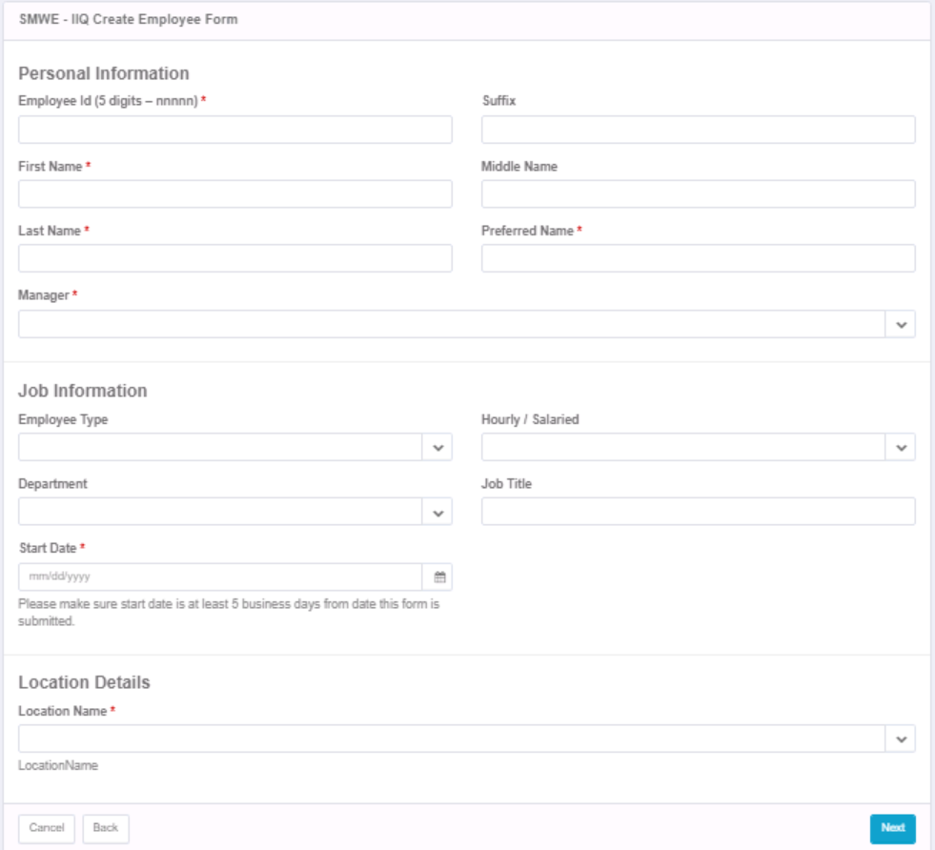

## Steps to access New Hire form

1. Quick link: SMWE - Employee Lifecycle >> Create Employee
2. A form will appear. Fill all necessary fields

|  |  |  |
| --- | --- | --- |
| **Section** | **Field Name** | **Allowed Values / Constrainst** |
|  | Employee ID | must be a 5-digit number |
| Personal Details | First Name (*) | - |
| Middle Name | - |
| Last Name (*) | - |
| Preferred Name (*) | - |
| Suffix | - |
| Manager (*) | dropdown  (All Identities) |
| Job information | Employee Type |  |
| Hourly / Salaried | - H - S |
| Full Time / Part Time | - Full Time - Part Time |
| Department |  |
| Job Title | - |
| Start Date (*) | - |
| Location Details | Location Name (*) |  |

1. Click on Next button
2. Validate all values (go back and update if required) >> click on Confirm.

It will create a new AD account of employee. An email notification is sent to new joiner’s manager with his/her loginid and password details (in separate emails). The OU is decided by the location field selected in form.

### Who will be able to access this link?

All members added to ‘SMWE – HR Workgroup’

## AD Account

### Login Id naming rules:

First 2 letters of firstname, first letter lastname, 2 numerical characters

The numbers at the end are incremented if its already taken. (it checks for ‘c-‘too, while checking for existing employee LIDs)

### Birthright groups:

1. CN=SMWE_Web_Access_Users,OU=Symantec Web Proxy, OU=ACLs,DC=SteMichelle,DC=ustis,DC=com
2. CN=SMWE All Users,OU=Users DL,DC=SteMichelle,DC=ustis,DC=com

## Attributes assigned?

Please see the sheet for list of attributes provisioned to AD during New hire



# Mover flow:

During Ultipro aggregation when SailPoint detects a change in existing active user’s attributes (last name, job title, location code, department), it updates the identity in SailPoint and triggers a mover workflow.

Mover workflow updates the changed attributes (last name, job title, location code, department) in user’s AD account.

## Attributes updated:

below set of attributes are updated based on changes in user record in Ultipro feed file. (The same is also added to ‘Attributes.xlsx’)

|  |  |  |  |
| --- | --- | --- | --- |
|  | **Source** | **Target** | |
| **#** | **Ultipro Attributes** | **Active Directory Attributes** | **Azure (o365) Attributes** |
| 1 | Org_Level_4 (department code) | departmentNumber | NA |
| 2 | Location_Code | distinguisedName  user's OU is updated based on location code | NA |
| 3 | Job_Code | title | NA |
| 4 | Last_Name | sn | last name when updates synced via Azure connect |
| mailNickname | mailNickName |
| proxyAddresses | proxyAddresses |
| userPrincipalName | userPrincipalName |
| mail | Mail |

Mail related attribute’s structure:

|  |  |  |  |
| --- | --- | --- | --- |
| **#** | **Mail related attributes (updated on last name change in Ultipro)** | **Structure** | **Notes/example** |
| 1 | mailNickname | First_name.Last_name | if a similar value is already present in system, sailpoint will append a number.  Eg, *Folo.Tolo* is already present, next will be *Folo.Tolo1* |
| 2 | proxyAddresses | SMTP:<value of mailNickname>@emailDomain | the existing proxy address with primary SMTP (caplital letlers), will be made seconday (smtp, in small letters). |
| 3 | userPrincipalName | <value of mailNickname>@emailDomain | [Folo.Tolo1@smwedev.com](mailto:Folo.Tolo1@smwedev.com) |
| 4 | mail | <value of mailNickname>@emailDomain | [Folo.Tolo1@smwedev.com](mailto:Folo.Tolo1@smwedev.com) |

**What if user does not have an AD account?**

New AD account will not be created.

**Email notification:** An email notification will be sent to user’s manager when there is a change in user’s *department* or *job code*. (no mail notifications are sent for last name and location change)

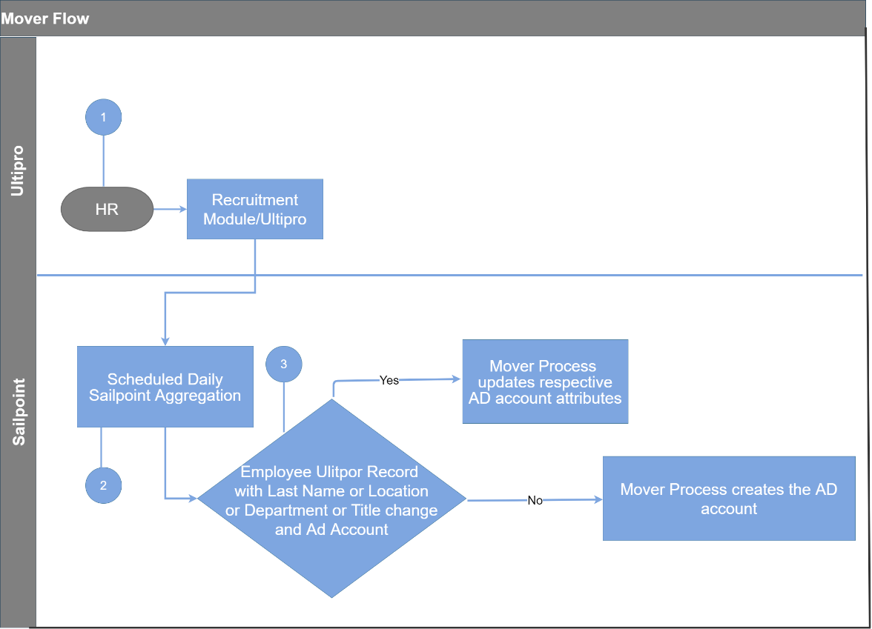

# Active to LoA

During Ultipro aggregation when Employee_Record_Type attribute of an active employee changes to ‘L’, SailPoint triggers a LoA workflow.

**Process:**

* AD’s comment attribute is updated – ‘*This user is in LoA status’* and
* mailbox retention is enabled.
* If this is a Salaried employee (Hourly_Salaried value S, in core file), then AD account is disabled.

Note: no action will be taken if user does not have an AD account.

# Active to Furlough

During Ultipro aggregation when Employee_Record_Type attribute of an active employee changes to ‘F’, SailPoint triggers a Furlough workflow.

**Process:**

* AD’s comment attribute is updated – ‘*This user is in LoA status’*,
* mailbox retention is enabled and
* AD account is disabled.

Note: no action will be taken if user does not have an AD account.

# Active to Hold

During Ultipro aggregation when Employee_Record_Type attribute of an active employee changes to ‘H’, SailPoint triggers a Hold workflow.

**Process:**

* AD’s comment attribute is updated – ‘*This user is in Hold status’*,
* Password is reset and sent to manager in email.

Note: no action will be taken if user does not have an AD account.

# LoA to Active

During Ultipro aggregation, when SailPoint finds a previously ‘LoA’ user in ‘A’ (active) state, it triggers a workflow and performs below process-

**Process:**

* Empty the comment attribute of AD
* mailbox retention will be disabled after 90 days.
* If this is a Salaried employee (Hourly_Salaried value S, in core file),
  + AD account is enabled,
  + Password is reset and sent to manager in email.

Note: no action will be taken if user does not have an AD account.

# Furlough to Active

During Ultipro aggregation, when SailPoint finds a previously ‘F’ (Furlough) state user in ‘A’ (active) state, it triggers a workflow and performs below process-

**Process:**

* Empty the comment attribute of AD,
* mailbox retention will be disabled after 90 days,
* AD account is enabled and
* Password is reset and sent to manager in email.

Note: no action will be taken if user does not have an AD account.

# Hold to Active

During Ultipro aggregation, when SailPoint finds a previously ‘H’ (Hold) state user in ‘A’ (active) state, it triggers a workflow and performs below process-

**Process:**

* Empty the comment attribute of AD and
* Password is reset and sent to manager in email.

Note: no action will be taken if user does not have an AD account.

# Termination

During Ultipro aggregation, when SailPoint finds a previously active user in ‘S’ (separated) state, it disables the identity in SailPoint & Ultipro application and triggers a leaver workflow.

**Leaver process**:

* All accounts of user are disabled.
* User’s AD password is reset.
* A process is scheduled to delete user’s AD and Azure account after 10 days of termination.
* A request is created in ServiceNow to perform further manual actions.
* An email is sent to user’s manager informing about termination along with password and ServiceNow request number.

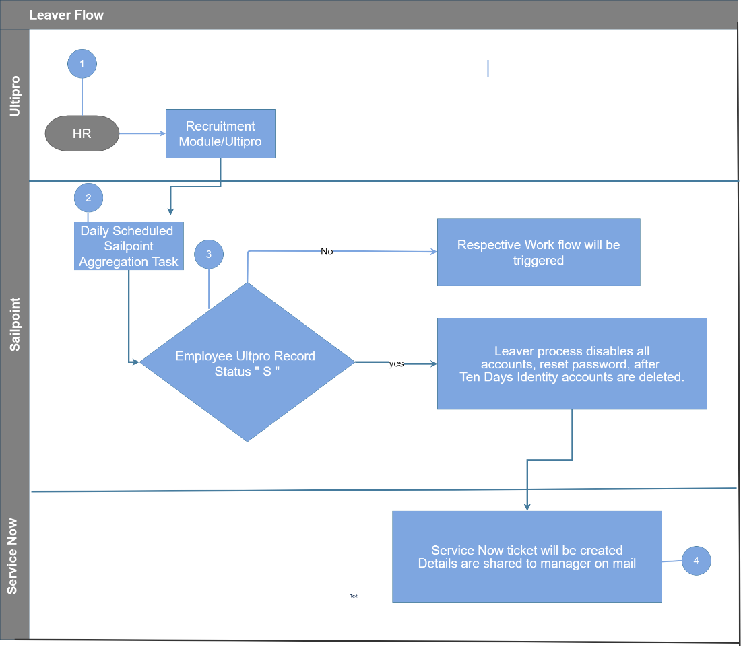

# Re-hire (Termination to Active) Process

Terminated employees existing in SailPoint can be re-hired using below form. Fields marked with a (*) are mandatory, rest are optional.

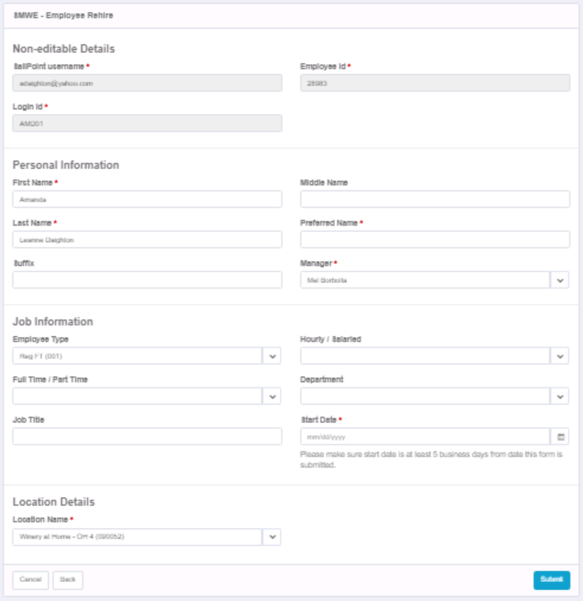

## Steps to access Re-hire form

1. Quick link: SMWE - Employee Lifecycle >> SMWE – Rehire
2. Select a user
3. A form will appear (all fields will be populated with employee’s existing information). Enter/update all necessary fields

|  |  |  |
| --- | --- | --- |
| **Section** | **Field Name** | **Allowed Values** |
| Personal Details | First Name (*) | - |
| Middle Name | - |
| Last Name (*) | - |
| Preferred Name (*) | - |
| Suffix | - |
| Manager (*) | dropdown  (All Identities) |
| Job information | Employee Type |  |
| Hourly / Salaried | - H - S |
| Full Time / Part Time | - Full Time - Part Time |
| Department |  |
| Job Title | - |
| Start Date (*) | - |
| Location Details | Location Name (*) |  |

1. Click on Submit
2. Validate all values (go back and update if required) >> click on Confirm.

### When will re-hire requests be processed?

All re-hire requests will be processed in nightly aggregation tasks.

### Who will be able to access this link?

All members added to ‘SMWE – HR Workgroup’

### Which identities will be available for re-hire?

All inactive employees.

## AD Account of re-hire employee

AD account will be created as it is created for new hires along with same birthright groups.

## Internal logic

After submitting the form entered data is saved to CSV file named ‘Sailpoint_Generated_Talent_File.csv’. This file is merged with core file during nightly merge process. Employee data is maintained in two different files –

* Core file – contains existing employees (shared by SMWE)
* Talent file – re-hired users, unless they are active in core file (generated by SailPoint)

To read whole employee data into SailPoint, it is required to merge core and Talent file records into a single feed file.

The records coming in Core file are read as they are. Each record of Talent file is compared against the Employee ID (of each record) in core file.

1. In case of a match if core file record is in Terminated state (Employee_Record_Type – S)
   1. Talent file’s record gets priority and
   2. it is written to Merged file in Active state.
2. In case of a match if core file record is in Active state (Employee_Record_Type – A)
   1. Core file’s record gets priority,
   2. it is written to Merged file in Active state (Employee_Record_Type – A) and
   3. Talent file’s record is deleted
3. When Talent file’s employee ID is not found in Core file
   1. It is simply written to Merged file in Active state (Employee_Record_Type – A)

# UPN and mail attributes when last name have two parts

The space character will be removed from last name while generating UPN and mail attributes.

# Ultipro aggregation:

* Scheduled at: 12 AM PST
* File: \\SMWECSMIAM02\Uploads\UltiproToSailPoint\Merged_file\Ultipro.csv
* Key: Employee ID
* If SailPoint finds a record with new Employee ID, it creates a new identity in SailPoint.
* If an identity is already present in SailPoint with same Employee ID, it will update the identity with feed file’s attributes.

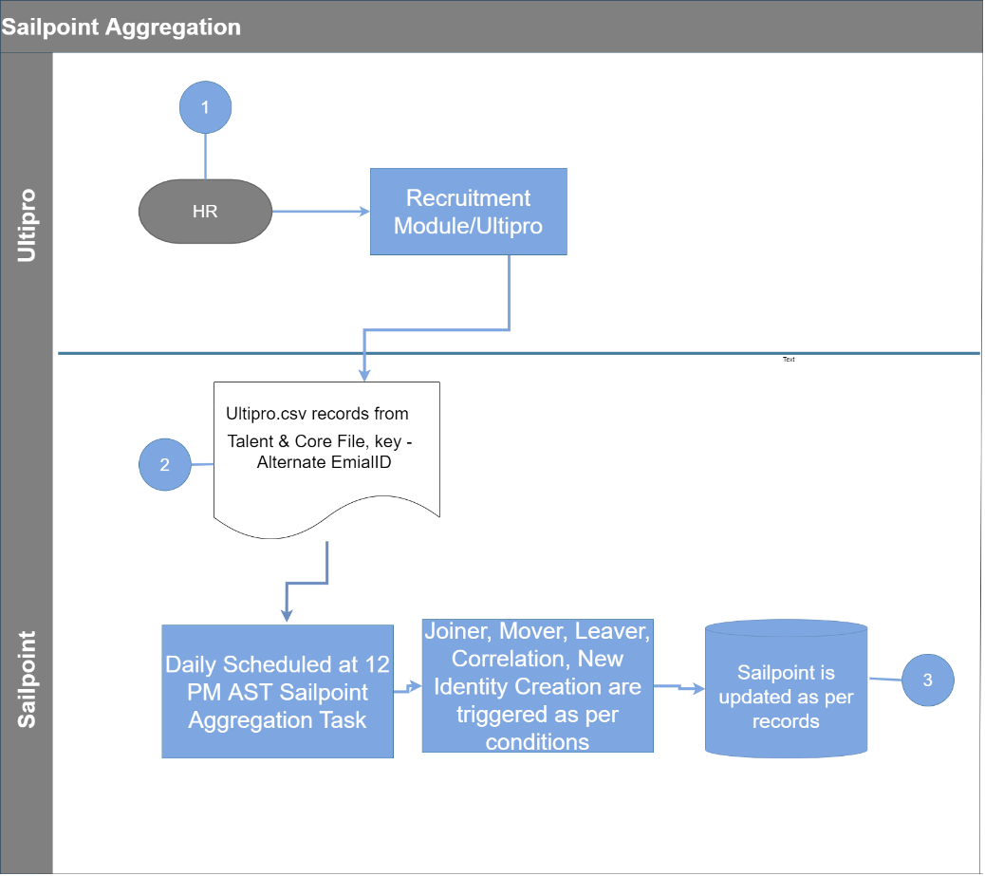

## What if user record is removed from core file?

Currently SailPoint does not perform any change in user’s identity if it is removed from core file.

# Active Directory Aggregation:

Like Ultipro account aggregation there is AD aggregation, which pulls all AD user accounts/service accounts from the given OUs (listed in blueprint doc). While pulling AD accounts, if they have employee Id field updated in AD, then SailPoint will find if there is any existing identity which has that employee id (obtained thru Ultipro aggregation process) and then correlate that AD account to that identity; once this correlation happens, then updates from Ultipro core file feed for such users would flow thru to AD for below listed attributes.

If employee Id is not present in AD, then SailPoint would create a new identity and put this AD account under that identity. (if this is an employee account, then Ultipro updates will not flow thru correctly as there is no match; if this is a contractor account, then no issues, as updates comes from Service now and SailPoint will update AD record)

# Attribute Sync (from SailPoint to AD):

SailPoint reads all employee data from Ultipro feed file, updates identity attributes and then syncs - address, manager, employee ID and mobile no. attributes to AD (whenever there is a change)

|  |  |  |  |  |
| --- | --- | --- | --- | --- |
| # | Ultipro attribute | SailPoint attribute | AD attribute | Format |
| 1 | Mobile_Phone | mobile | Mobile | - |
| 2 | Building_Street_1 | Address | postalAddress | - |
| 3 | Report_To_Employee_Number | managerid | manager | - |
| 4 | Personnel_Number | employeeID | employeeID | - |
| 5 | Work_Phone | WorkPhone | telephoneNumber | - |
| 6 | Source_Job | title | title | - |
| 7 | Source_Job | title | description | Login ID -- title |

**Conditions for manager update:** there should be a unique and active manager identity in SailPoint. Failing to meet these conditions may wipe out manager in AD.

(the check to pick only active manager identities is added recently, in response to ticket# INC0845463) because we got 400+ duplicate records in Ultipro feed file. Due to which SailPoint could not find a unique identity for manager’s employee ID and pushed an empty value in AD’s manager field.)

**When does SailPoint wipe out manager in AD**: if SailPoint cannot find a unique identity for manager, it will push a blank or empty value to AD’s manager field. This may happen when:

* there are duplicate active identities for manager in SailPoint (cannot find a unique value).
* SailPoint cannot find an active identity with manager’s employee ID.
* Manager’s Ultipro and AD accounts are not correlated. (SailPoint will find an identity but will not be able to find a DN to push)

**Managers sync internal working:** We have a rule ‘SMWE - Manager IdentityAttributeTarget’ for manager sync to AD. This picks up manager’s employee ID from Ultipro feed, searches for an identity with that employee ID and returns manager’s DN. SailPoint processes this rule on each refresh task run and pushes to AD whenever it finds a mismatch between the manager in AD and the DN returned form the rule.

# SailPoint Identity Attributes:

Along with account attributes (like Ultipro, AD), SailPoint also stores user information in identity attributes. These are read from applications (Ultipro/AD/Azure) and used in SailPoint internally for fast access of user data.

High level flow: Application -> SailPoint identity

See below sheet for list of identity attributes and their Source application/attribute combination



